**E-Box Plugin to VS Code**

Step 1 – Download VS Code version – (VSCodeUserSetup-x64-1.54.3)

Download link- [*https://update.code.visualstudio.com/1.54.3/win32-x64-user/stable*](https://update.code.visualstudio.com/1.54.3/win32-x64-user/stable)

Step 2 – Go to <https://hcl.e-box.co.in/> and download plugin (VS Code) version – (ebox-0.0.9.vsix)

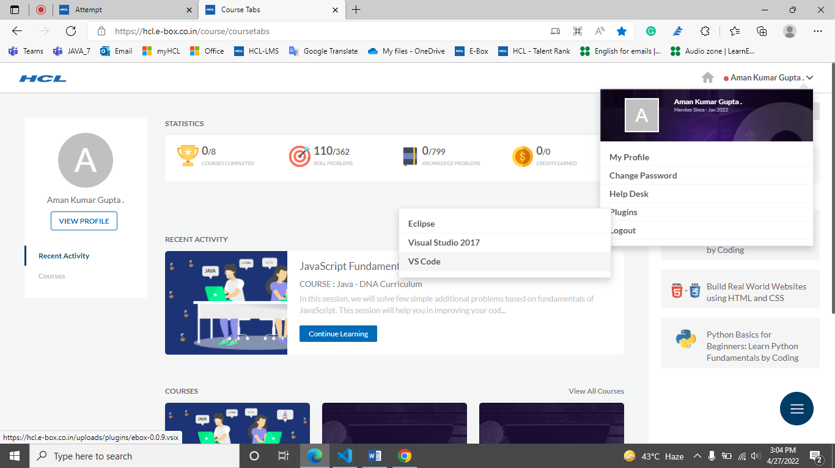

Step 3 - Install VS Code, and turn off all auto updates from Setting by pressing by ‘Ctrl + ,’ or by go to setting button.

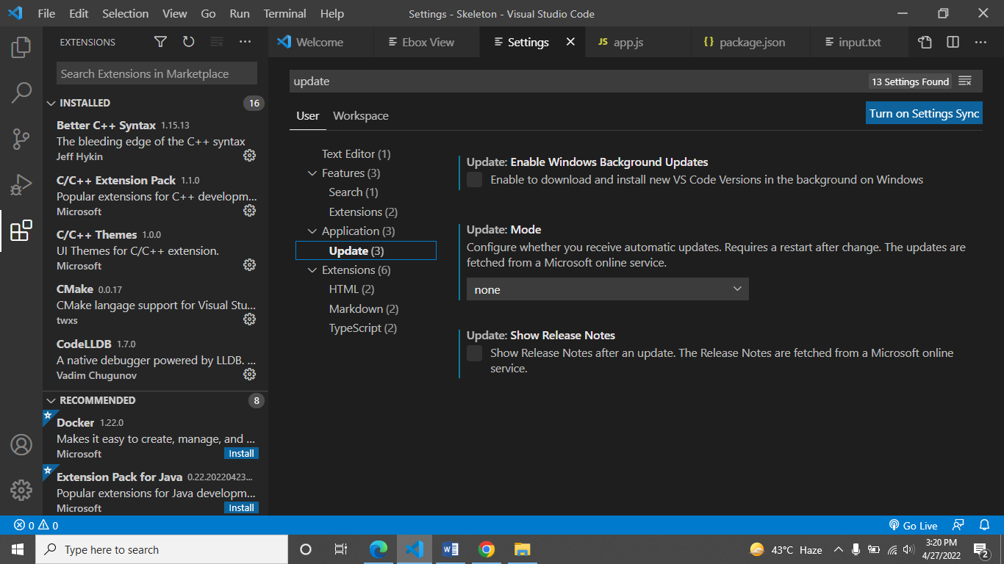

Step 4 - Create any folder or workspace and open it by pressing ‘Ctrl + O’ or from file option.

Step 5 – After opening folder or workspace go to Extensions button in VS Code and inside Extensions find three dots top right corner and Select ‘Install from VSIX…’

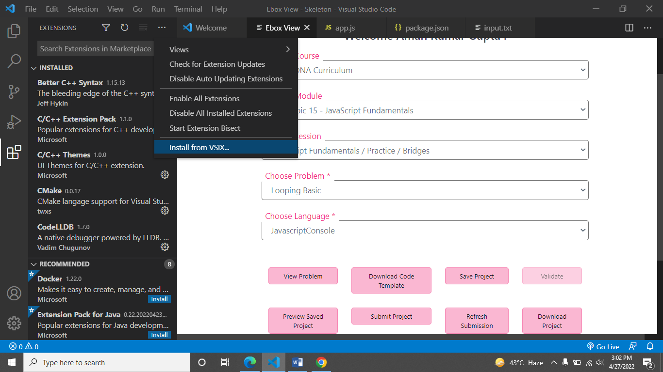

Step 6 – Select the plugin (ebox-0.0.9.vsix) and open it, after successful installation a popup notification is there.

Step 7 – Press Ctrl + Shift + P and search for ‘Ebox’ and click enter after this window will be showing..

